AI Internship Application Coach
  - Project architecture and implementation guide
Project baseline 30 October 2026
This guide gives collaborators and evaluators a common understanding of the application, its data flow, component responsibilities and planned repository structure. The agreed stack is the existing Firstrole frontend, a Python FastAPI backend, Supabase PostgreSQL and n8n coaching workflows.
A visitor uploads a resume, chooses a company and role, reviews a tailored cover letter, and explicitly approves or rejects it. Only an approved version becomes a saved application and can be downloaded. The system does not send an email or submit an application to an employer.

Current implementation status
Component | Status at this baseline
Frontend | Built locally with upload, selection, review, approval and download UI. Real backend connection pending.
Frontend checks | 46 browser checks passed against synthetic API responses. These are not live AI or database tests.
MCP workflow | Import JSON created with three tools. 278 local code and structure checks passed; live import and retrieval unverified.
Supabase | Selected as PostgreSQL host. No project/database connection has been provisioned in this work.
Python backend | API contract and architecture planned. Implementation and durable processing are pending.
Remaining workflows | Knowledge Loader, Coach API and Error Monitor are planned. No deployment or GitHub push completed.

How to use this guide
Read the journey and architecture first. Use the workflow, database and API sections to divide implementation work. The folder trees distinguish files that exist from proposed files, so a planned path is not mistaken for working code. Finish with the delivery checks before describing the project as production ready.

User journey and approval flow
The initial page contains an empty upload form. There is no prewritten letter or testing resume loaded into the product. Every generation request must use the file selected for that request.
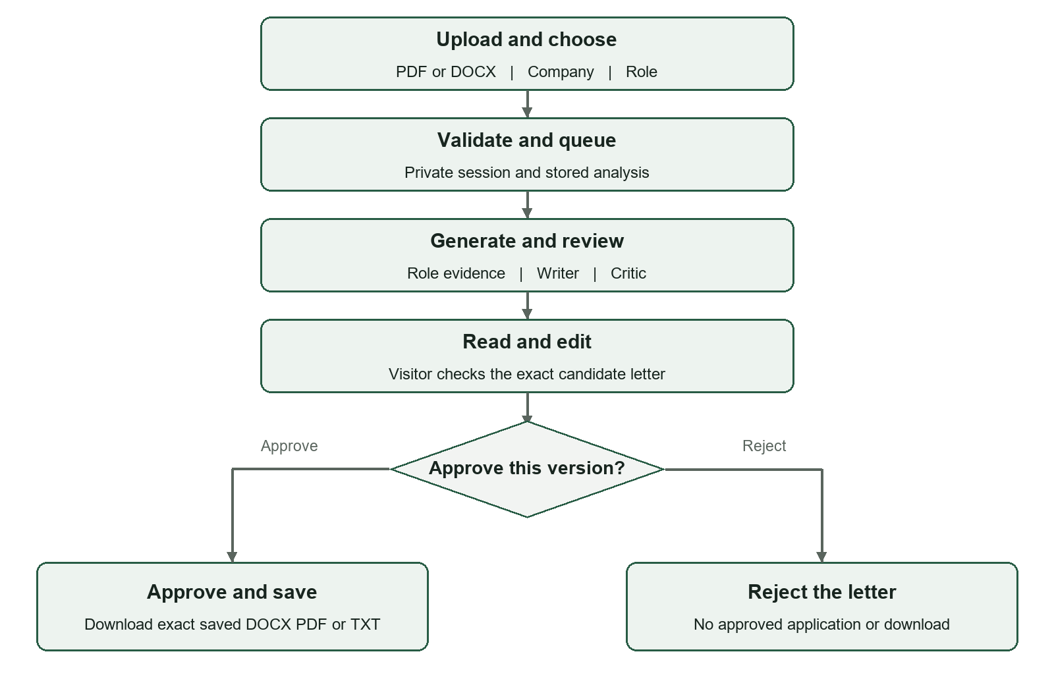
Figure 1 Visitor flow from a new upload to an explicit approval or rejection

Expected behavior
- Accept one non-empty PDF or DOCX up to 5 MB. Company selection controls the available roles. The current development catalog has five companies and fifteen fictional roles.
- Display genuine processing status and actionable errors. Missing role evidence, unreadable files and model failures must not produce a fake successful letter.
- Allow editing before approval. Any edit clears the confirmation checkbox. Approval binds to the exact visible wording, not an older draft.
- After approval, offer DOCX, PDF and TXT. Body paragraphs are justified; salutation and signature remain left aligned in the browser and exported documents.
The goal is a specific, complete letter suitable for the visitor to review and use. Model output is not a guarantee of factual perfection; the visitor remains responsible for confirming every claim.

System architecture and responsibilities
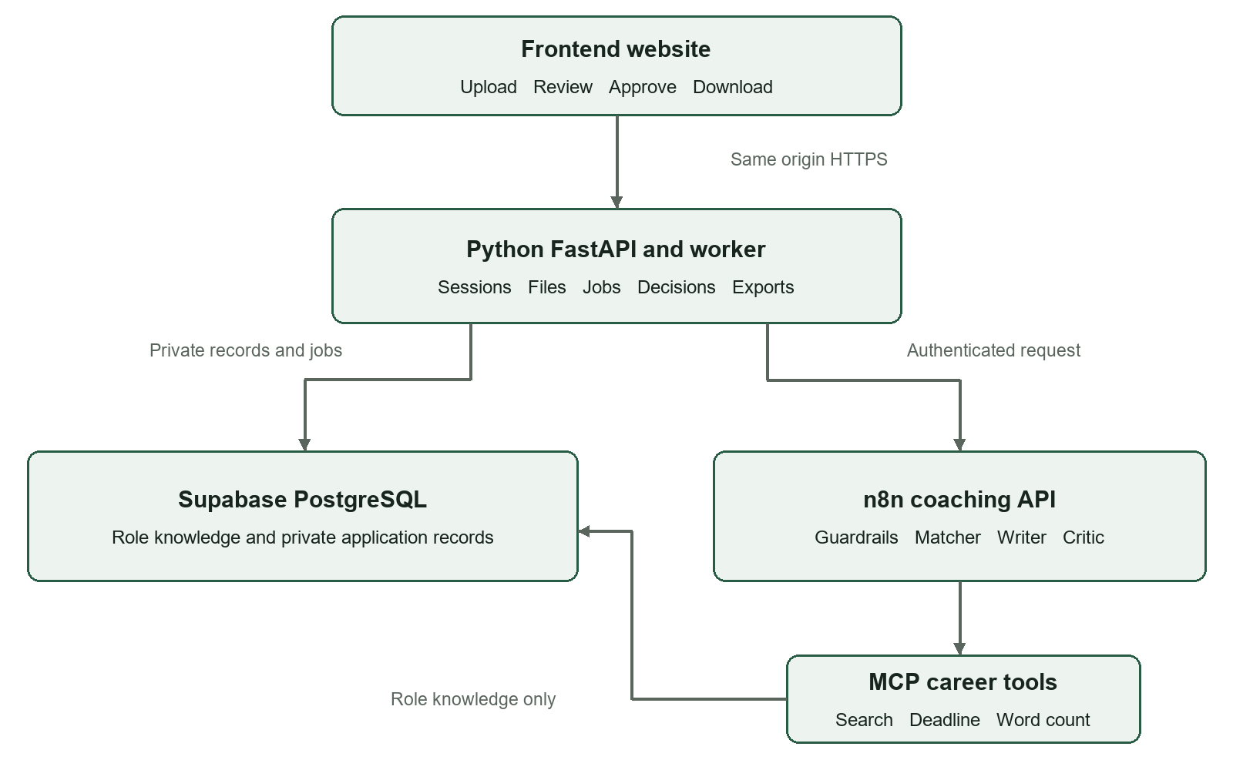
Figure 2 Application boundaries and server to server connections
Component | Responsibility
Frontend | Collect the current upload and selection; show status and results; collect an explicit decision; request approved exports.
Python API and worker | Enforce ownership, validate/extract files, queue durable jobs, call n8n, validate results, save approved text and generate exports.
Supabase PostgreSQL | Persist authoritative catalog, role documents, vector chunks, private analyses, jobs, decisions and applications.
n8n and MCP | Run the bounded AI pipeline and narrowly scoped evidence/calculation tools. Return structured results to Python.

Supabase provides database and backend services, but it does not automatically implement this application. FastAPI remains the custom Python layer required for file handling, approval rules and exports. It runs on a separate Python host. Supabase Edge Functions use TypeScript/Deno and are not required in this baseline.

n8n workflows and AI stages
Workflow name | Purpose and execution
Workflow 1 Internship Knowledge Loader | Administrator-controlled document validation, splitting, embedding and indexing. Runs when sources change, not on every resume upload.
Workflow 2 Internship Career Tools | Authenticated MCP server exposing role search, deadline calculation and exact-text word count. Import JSON exists locally.
Workflow 3 Internship Coach API | Authenticated request from Python, input validation, PII sanitization, guardrails, matching, drafting, criticism and structured response.
Workflow 4 Internship Error Monitor | Safe metadata for failed automatic executions. Operational support with no extra model stage on successful requests.

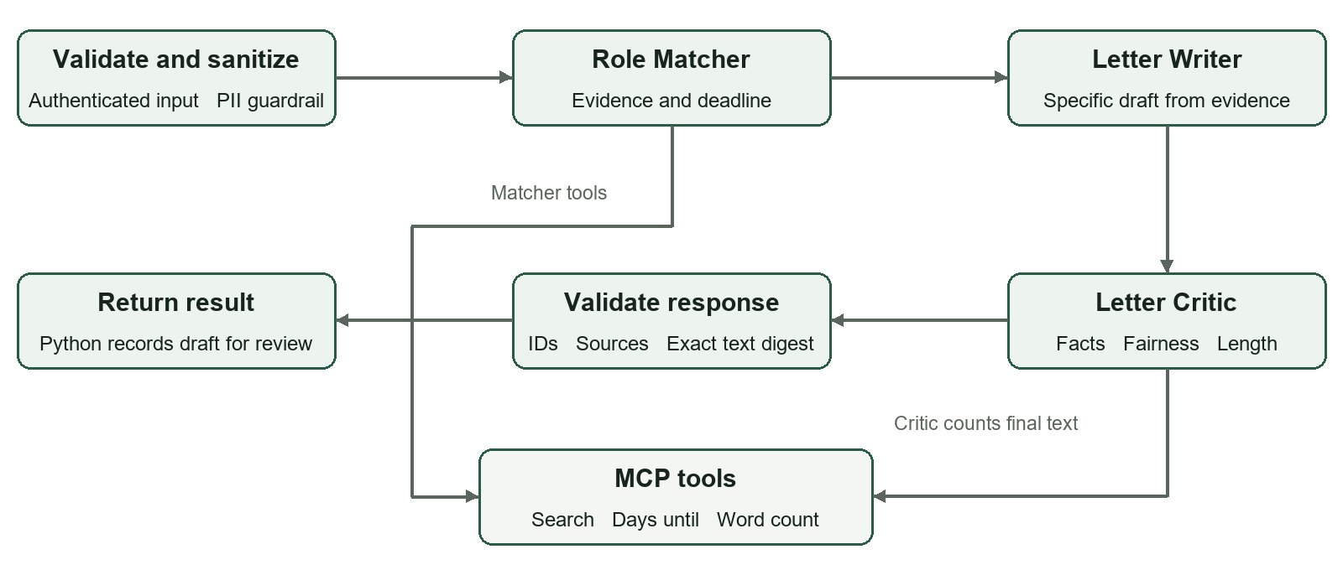
Figure 3 Planned coaching pipeline and its selected MCP tools
The matcher uses retrieved role evidence and resume experience. The writer uses that evidence to draft under 250 words without invented qualifications. The critic checks relevance, fairness, unsupported claims and length. At least one agent must choose its tools; the writing stage may use a simple LLM node.
Keep stages explicit, limit agent iterations and allow at most one controlled revision pass. A revision changes the candidate text and therefore requires a new count/review. Do not add a supervisor that repeatedly redispatches completed work.
MCP contracts: search_internship_roles accepts input plus an exact role_id and returns source metadata. days_until accepts an ISO date and computes calendar days in Asia/Kolkata. word_count accepts the exact final text and returns its count and SHA-256 digest. Select only the tools each agent needs.

Database design in Supabase
PostgreSQL stores the records; pgvector stores embeddings for role retrieval within the same database. A table is a typed collection of rows. A foreign key connects one record to another, such as an application to its analysis and owner.
Record or table group | Stored information
Companies and internship roles | Stable company/role IDs, titles, requirements, deadlines, active state and catalog version.
Source documents | Original role text, source title, version and ingestion status.
public.internship_role_chunks | Passage text, role/source metadata and a 3072-dimension embedding. Matches the current MCP import.
Visitors and sessions | Anonymous owner ID and hashed session secret with expiry. The raw secret stays in an HttpOnly cookie.
Resumes | Owner, filename, actual type/size, digest, encrypted original bytes and encrypted extracted text.
Analyses and jobs | Resume/role links, authoritative role snapshot, processing stage, retries/lease, draft version, letter and review result.
Approval decisions | Exact submitted version/text hash, owner, approve/reject outcome and decision timestamp.
Applications | Immutable approved wording, text hash, role snapshot, approval time and source analysis.
Idempotency records | Request key bound to owner, route and payload so repeated requests do not create duplicates.

Ownership and relationships
One visitor owns multiple resumes and analyses. An analysis refers to one resume and selected role version. A finalized analysis can produce at most one approved application. Every private read, decision and download must check the current owner, even when its record ID is known.

Persistence and file storage
For the current 5 MB cap, original resume bytes can be stored privately in PostgreSQL. Supabase Storage remains an optional later decision, not an assumption in this design. Generate exports from saved text rather than keeping duplicate files. Drafts/jobs are stored before approval for reliability; they are distinct from approved applications. Agree retention and deletion rules before public launch.

API contract and durable processing
The existing frontend expects same-origin routes under /api. Python is the owner of that public application boundary. n8n endpoints and credentials are server-side configuration and are never supplied by the browser.
Method and route | Result
GET /api/session | Create/resume the anonymous session and return a CSRF token.
GET /api/companies | Read available companies from PostgreSQL.
GET /api/roles?company=... | Read allowed roles for the selected company.
POST /api/analyses | Validate multipart upload, store request and queue job; promptly return HTTP 202 and analysis_id.
GET /api/analyses/{id} | Owner-only queued, processing, failed or ready state, with a complete result when ready.
POST /api/analyses/{id}/decision | Validate owner, draft version, exact text, decision and idempotency; commit before confirming approval.
GET /api/applications/{id}/download | Owner-only approved DOCX/PDF/TXT with the correct MIME type.

Data sent to n8n
analysis_id, request_id, company, role_id, catalog_version
resume_text from this upload, candidate_name
current_date, timezone

n8n returns matching IDs, final_letter, match_report, source references, deadline_info, critic_review, structured tool evidence and approval_allowed. Python validates and wraps this as the frontend result, adding its draft version. Invalid JSON, missing evidence or mismatched roles become controlled failures.

Jobs and approval
Use a PostgreSQL-backed worker queue with short claiming transactions, leases and bounded retries. Network/model work runs outside database transactions. Return processing status to the page instead of holding a long browser request open. A timeout does not prove remote work never happened; retry only with safe deduplication.
Approval locks and checks the analysis, validates the submitted version, inserts its decision and saves the exact letter in one transaction. Conflicting decisions fail. Rejection creates no approved application. Add owner-scoped recent-record and deletion routes when persistence is connected, updating the frontend contract together.

Repository and frontend file structure
The following repository structure is the target layout. Existing means a local file/directory is present; planned means it still needs implementation. No remote folder or deployment is implied by this tree.
ai-internship-application-coach/
|-- frontend/ existing local UI and browser checks
|-- backend/ planned FastAPI API and worker
|-- supabase/ planned versioned database migrations
|-- workflows/ MCP JSON exists; other exports planned
|-- role_documents/ planned versioned role source files
|-- docs/ this guide and future runbooks
|-- .github/workflows/ci.yml planned CI checks
|-- .gitignore existing
|-- .env.example planned names only, no secrets
|-- compose.yaml planned local API worker database setup
`-- README.md existing stub; expand during integration

Frontend files that exist locally
frontend/
|-- index.html
|-- package.json
|-- README.md
|-- API_CONTRACT.md
|-- DEVELOPMENT_NOTES.md
|-- assets/
| |-- css/styles.css
| |-- data/roles.json local development catalog only
| `-- js/
| |-- app.js screens and processing flow
| |-- api.js HTTP calls and CSRF header
| |-- state.js tab state and safe letter rendering
| `-- components/
| |-- intake.js file and company role selection
| |-- review.js editing and confirmation
| |-- approval.js server confirmed decisions
| `-- downloads.js approved exports and clipboard
|-- tools/dev-server.mjs
`-- tests/browser-check.cjs

The local catalog fallback and synthetic test API remain development aids. Production reads the catalog and saved records from the backend. No real resume, sample letter or secret belongs in these frontend assets. The current UI is plain HTML, CSS and JavaScript modules; no React conversion is required.

Python backend file structure
All paths on this page are planned. Keep route handling, business rules, data access and the n8n adapter separate so each can be tested without a live model call.
backend/
|-- pyproject.toml
|-- uv.lock locked Python dependency versions
|-- Dockerfile deploy API and worker from one image
|-- .env.example
|-- README.md
|-- app/
| |-- __init__.py
| |-- main.py API setup and frontend serving
| |-- config.py validated environment settings
| |-- db.py SQLAlchemy sessions and pools
| |-- worker.py durable job processing entry point
| |-- api/
| | |-- dependencies.py ownership and CSRF
| | |-- sessions.py
| | |-- catalog.py
| | |-- analyses.py
| | |-- applications.py
| | `-- health.py
| |-- models/ mapped PostgreSQL records
| | |-- identity.py
| | |-- knowledge.py
| | `-- application.py
| |-- schemas/ validated request response models
| | |-- catalog.py
| | |-- analyses.py
| | `-- applications.py
| `-- services/
| |-- sessions.py anonymous identity and cookies
| |-- uploads.py actual file and archive validation
| |-- extraction.py PDF DOCX to text
| |-- jobs.py queue leases attempts and recovery
| |-- coaching.py authenticated n8n adapter
| |-- approval.py exact version database transaction
| |-- exports.py genuine DOCX PDF TXT
| `-- retention.py explicit cleanup and deletion
|-- scripts/import_catalog.py
`-- tests/
|-- unit/
|-- integration/ real PostgreSQL with pgvector
`-- fixtures/ synthetic resumes and letters only

Suggested libraries and migration ownership
Use FastAPI/Pydantic, SQLAlchemy/psycopg, python-docx, pypdf and ReportLab, with compatible versions locked when implementation begins. Text extraction must reject empty, malformed, encrypted or unsupported documents clearly. Scanned PDFs need a separately implemented OCR path; do not silently treat them as successfully extracted.
Keep SQL schema migrations in the supabase directory described next. They are the single authoritative migration history. Do not maintain independent Alembic and Supabase migrations for the same tables.

Database and workflow file structures
Use one versioned SQL migration history that can be applied to Supabase and to a real PostgreSQL development/test environment. Migration files define schema changes; they do not contain connection secrets or real user data.
supabase/ planned
|-- config.toml local CLI configuration
|-- README.md
|-- migrations/
| |-- <timestamp>_knowledge.sql
| |-- <timestamp>_catalog.sql
| |-- <timestamp>_identity.sql
| |-- <timestamp>_analyses_and_jobs.sql
| |-- <timestamp>_approvals_and_applications.sql
| `-- <timestamp>_permissions.sql
`-- tests/
|-- constraints.sql
`-- permissions.sql

The supplied knowledge SQL is currently a standalone bootstrap script. When formal migrations are added, adopt its schema into that history and inspect any existing table first. CREATE TABLE IF NOT EXISTS is not a migration or schema-validation mechanism.
workflows/
|-- Workflow 1 Internship Knowledge Loader.json planned
|-- Workflow 2 Internship Career Tools.json exists
|-- Workflow 3 Internship Coach API.json planned
|-- Workflow 4 Internship Error Monitor.json planned
`-- mcp/ exists
|-- README.md
|-- prepare_knowledge_database.sql
|-- Validation Results.json
|-- tools/
| |-- days_until.js
| `-- word_count.js
`-- tests/
|-- validate.cjs
`-- roles_catalog.json test fixture

Role source documents and supporting files
role_documents/ planned versioned approved sources
|-- amazon.md
|-- microsoft.md
|-- google.md
|-- nvidia.md
`-- deloitte.md

docs/ planned runbooks beside this guide
|-- architecture.md
|-- api_contract.md
|-- database_setup.md
|-- n8n_setup.md
`-- deployment.md

Each company document contains three clearly identified fictional roles. If the evaluator requires the original five-role dataset instead, agree that scope before importing sources. Do not silently change the catalog or claim live vacancies.

Privacy safety and exact letter handling

Private access without a login page
The baseline uses a random anonymous identity managed by Python and an HttpOnly session cookie. Store only a hash of the secret server-side, with Secure cookies in production, SameSite settings and CSRF/Origin checks for mutations. Supabase Auth anonymous identities are an available alternative, but switching requires a coordinated API/session design change. The Supabase anon API key alone is not a visitor identity.
Records persist across refreshes and server restarts. Another browser/device, expired sessions or cleared cookies cannot recover that anonymous identity automatically. Decide whether to add a recovery code before public launch. A shared browser session also shares access. Test isolation with independent sessions, copied IDs and download URLs.

Data access and secrets
Give the MCP credential only the knowledge access it needs. The loader gets separate scoped knowledge-write access. Python accesses private application records. Schema migrations use an administrator identity outside routine requests. Supabase Data API exposure and permissions must be reviewed explicitly; keep private schemas unexposed unless properly protected by access policies.
Keep database passwords, encryption keys, MCP header secrets and n8n webhook secrets in server configuration/credential stores. Never place them in the browser, Git, SQL fixtures or exported workflow JSON. Supabase privileged secret/service-role credentials must never be shipped to frontend code. Use TLS verification and test backup restoration.

Model and document safety
Resume content is untrusted data, including any embedded instruction to change role, disclose secrets or ignore rules. Use a real Guardrails node, mask contact PII before model processing, judge fit by skills/experience and reject discriminatory criteria. Do not let tools read arbitrary private records or write applications. The model cannot assert approval on the visitor behalf.
SHA-256 from word_count binds a count to a normalized exact letter. Normalize CRLF/CR to LF consistently, then preserve wording through review, storage and export. A model statement saying a tool was called is not execution evidence. Recount and re-review changed final text; never silently rewrite an already approved version.

Operational logs and retention
The MCP import disables execution-payload saving because word_count receives letter text. Use synthetic text for detailed trace testing. Store safe error metadata and timing measurements without credentials or raw resume text. Any retention/deletion policy for uploads, drafts, anonymous sessions and approved records must be explicit rather than assumed permanent or silently purged.

Build sequence deployment and acceptance
Phase | Deliverable and completion check
1 Database and MCP | Create the development Supabase project, enable pgvector, prepare knowledge tables and connect restricted credentials. Index sources and test every expected role ID.
2 Coaching API | Build the authenticated webhook pipeline; test tools, sanitization, valid output, unknown roles, malformed JSON and bounded failure handling.
3 Python foundation | Implement sessions, database/catalog routes, real file extraction, durable jobs and the n8n adapter. Verify a different upload supplies fresh text.
4 Approval and exports | Save exact approved wording transactionally; test rejection, duplicate requests, racing decisions, export MIME types and document layout.
5 Frontend integration | Use real endpoints, remove production catalog fallback, restore owner records after refresh and preserve the existing approved visual design.
6 Deployment | Deploy the Python API plus worker, serve frontend/API through one HTTPS origin, apply versioned SQL and verify monitoring and backup restoration.

Acceptance checks before a public demonstration
- One upload and selection produces a role-specific letter from that resume. Test all fifteen role IDs and a missing ID; sources must match the chosen role.
- Two visitors cannot access each other records. Copying an analysis/application ID or download URL must not bypass ownership.
- Editing clears confirmation. Failed approval keeps downloads locked. Approve/reject races and repeated keys cannot create duplicate or conflicting saved applications.
- The saved text and downloaded wording match exactly. Check real DOCX/PDF rendering, Unicode names, paragraph breaks and justification.
- Queued work survives a service restart. Model/database failures produce useful status; no fake sample output, invented evidence or success without commit.

Performance and release evidence
Measure queue wait, extraction, retrieval, model calls, validation and export separately. The target remains fast generation, but under ten seconds is not guaranteed for a multi-stage external AI pipeline. Return the queued acknowledgment quickly and expose actual progress. Include p50/p95 generation measurements and model call/token counts in demonstration evidence.
GitHub receives code, migrations, sanitized workflow JSON, approved fictional role documents and test fixtures. Real resumes, secrets, database dumps and execution payloads stay out. Deployment is a separate action from pushing code; both remain pending.

Setup handover and technical references

What a collaborator needs first
Use the frontend README for local UI startup and browser checks. Import the MCP JSON using the mcp README, then select fresh header-auth, PostgreSQL and Gemini credentials. Run the knowledge bootstrap SQL as administrator only after choosing the correct development database. Search will remain empty until indexing is implemented and completed.
Keep database and MCP connection secrets out of chat. Share non-secret project identifiers and successful connection status with collaborators. Use separate development and production environments and verify node/extension/model compatibility before claiming an import or search is working.

Relationship to the original challenge
The design retains bounded agent behavior, three named tools, document retrieval, MCP, a Guardrails node, fairness rules and human approval. The original brief explicitly used Simple Vector Store, n8n approval forms and Data Tables. This web application deliberately replaces those with persistent PostgreSQL retrieval, website approval and Python-controlled storage. Obtain evaluator acceptance or maintain a separate course demonstration if those exact original nodes are mandatory.

Glossary
Term | Meaning in this project
API | The agreed HTTP interface between the browser, Python and the coaching service.
Webhook | The authenticated n8n endpoint that Python calls to start coaching.
MCP | Protocol through which the agents discover and call the selected tools.
RAG and embedding | Retrieve document evidence before drafting; an embedding is the numerical search representation of text.
Migration | A versioned, reviewable change to the PostgreSQL schema.
Idempotency | Repeating the same request key and payload returns the same outcome rather than duplicating it.

Primary technical references
Supabase platform and PostgreSQL services
Supabase pgvector extension
Supabase anonymous identities and their access limitations
n8n MCP Server Trigger and production endpoints
n8n Postgres PGVector Store
PostgreSQL backup and restore

